**Final Website Documentation**

We stuck to our draft and followed through with the design of our wireframes and paper prototype.

**Changes were:**

* We didn’t include a news section on the homepage
* Ticket page had adjustments, less of what we had in paper prototype
* Night zoo removed!
* Day pass, annual pass - not enough experience with coding forms
* Javascript - not enough knowledge on it to use in our website

**Target Audience**

As a team we have confidently designed a new and improved website for Wild Time Zoo. Covering all the requirements for the updated site and have hit the targeted audience. This website is informative to users that access this page even if it is to browse the different animals and look at the facilities the zoo has on offer.

**Navigation**

Our navigation responds well to each link that has been created. The layout of the navigation is user friendly, responsive and can get the tasks done with ease of use.

**Content**

For each of our pages we have informative content which is specific to the topics and our animals. A background on each animal has been introduced for our target audience

**Images**

We added two new images to our website. On our homepage there is a Gorilla, this is there because of the requirements, a new gorilla enclosure has recently been formed at Wild Time Zoo. We have also created 4 new images to highlight the zoo’s features using previously referenced images.

There is an education room within the zoo and an image that shows this facility, this was left out of our draft and realised it was part of the requirements, we included this image.

**Continuous Media**

Carousel of images on the homepage. Also the map of the zoo is included but isn’t interactive as such.

**Forms**

We managed to make a basic form for our tickets page. With lack of experience in this area we made do. Using the internet to aid in what we tried to incorporate in the tickets page, fell short in how we had designed it in the wireframes as well as the paper prototypes.

**Documentation (screenshots)**

Homepage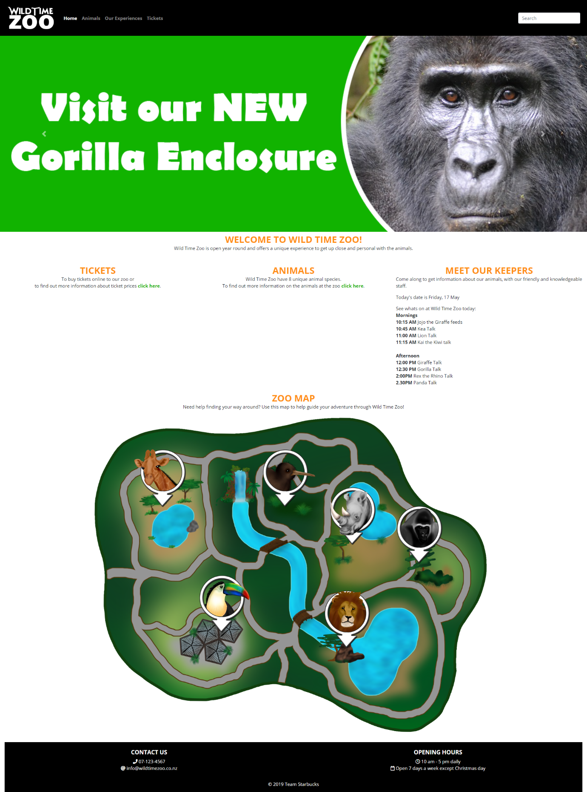

Animals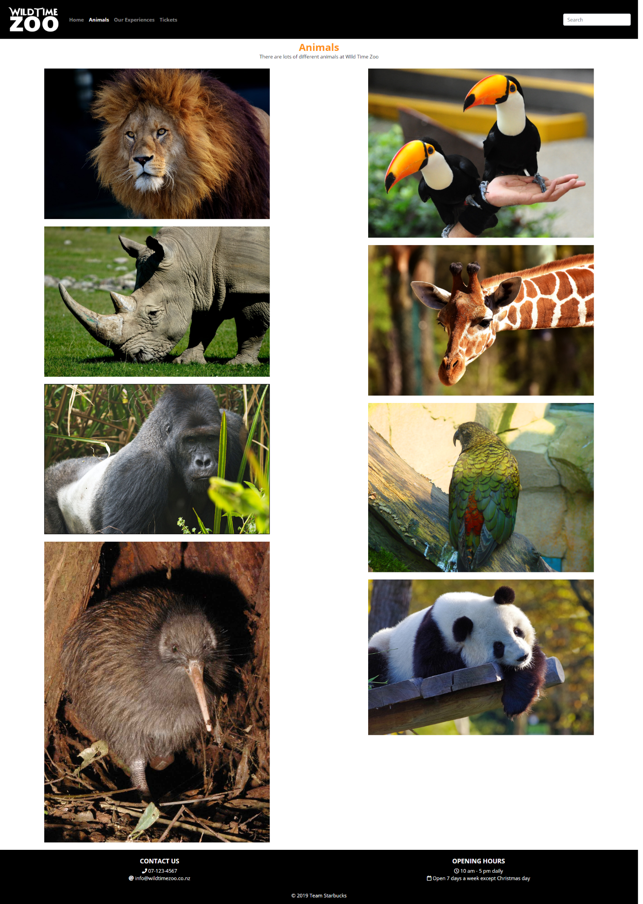

Our Experiences 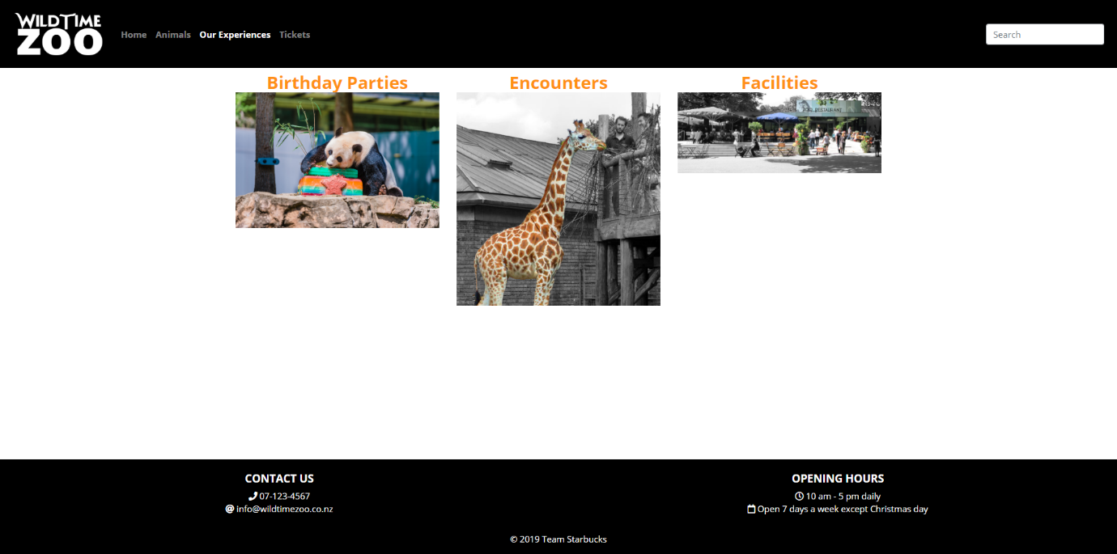

Tickets 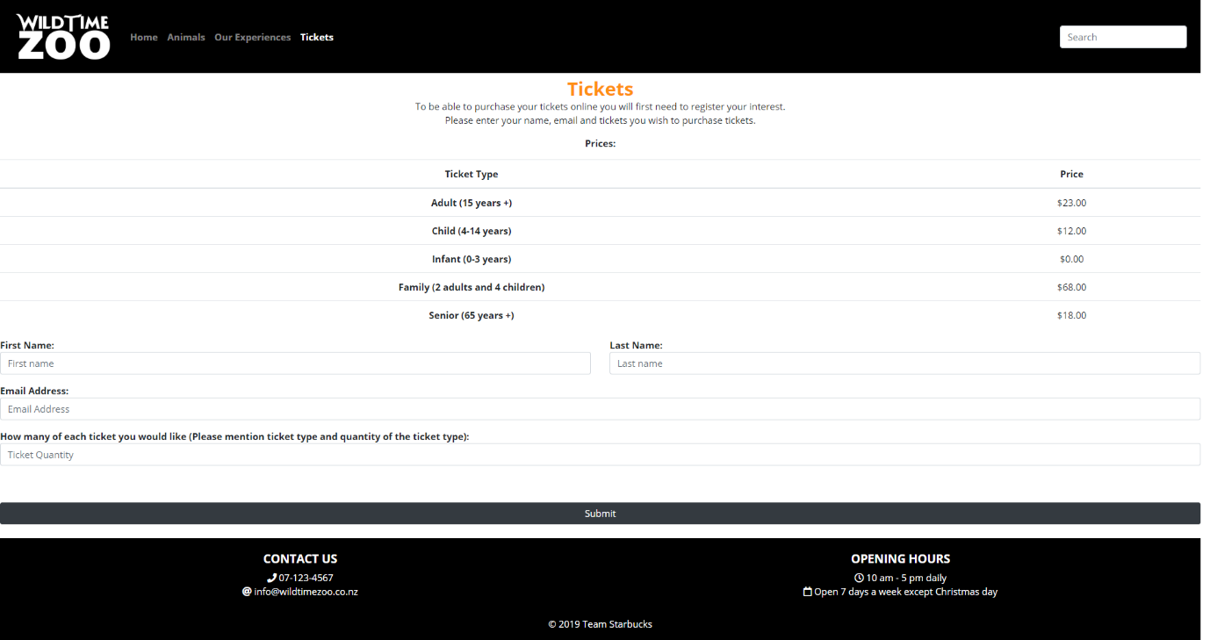

Lion 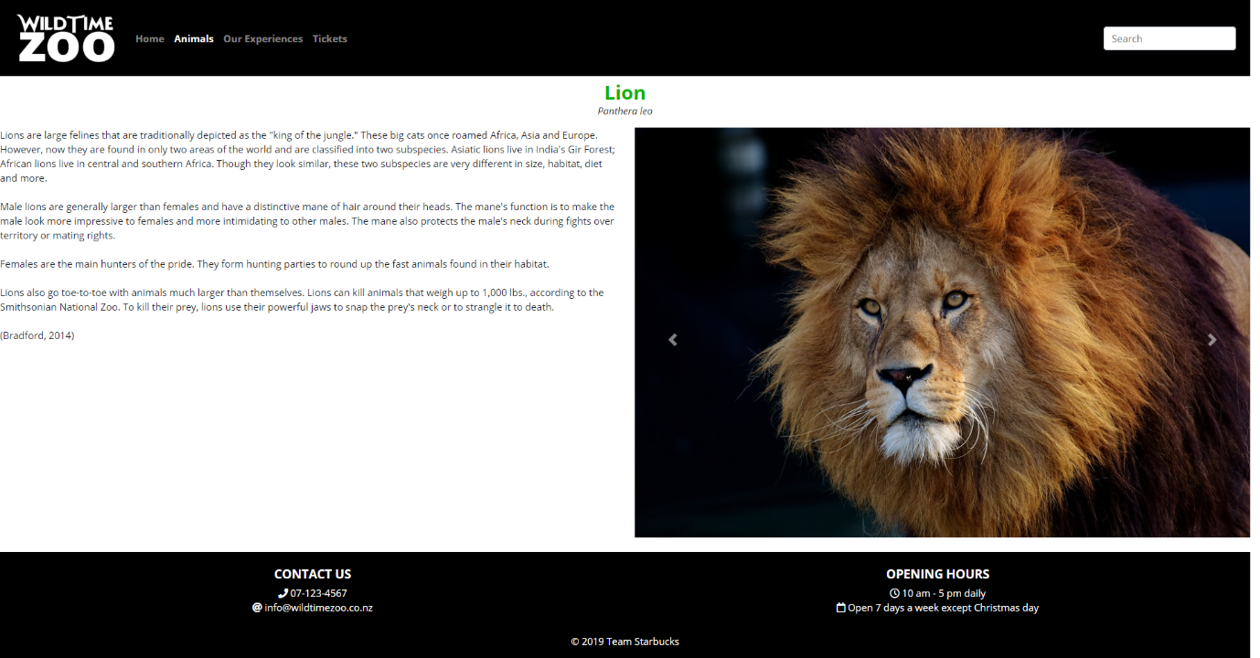

Toucan 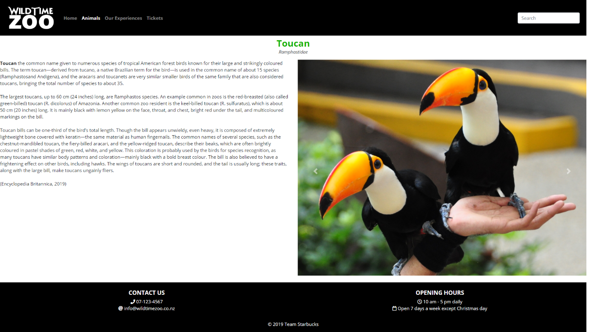

Rhino 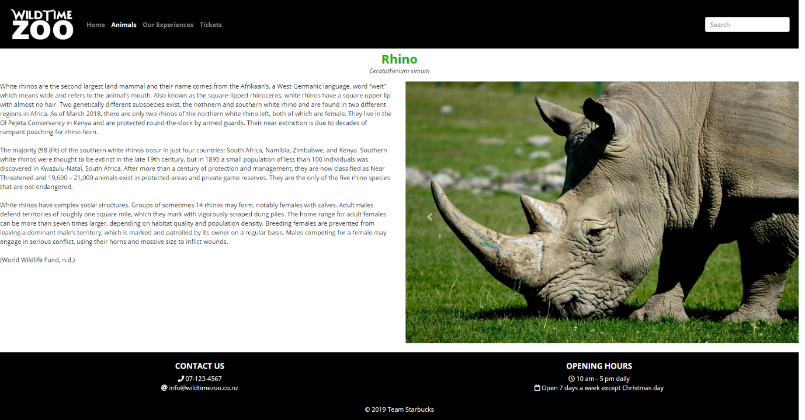

Gorilla 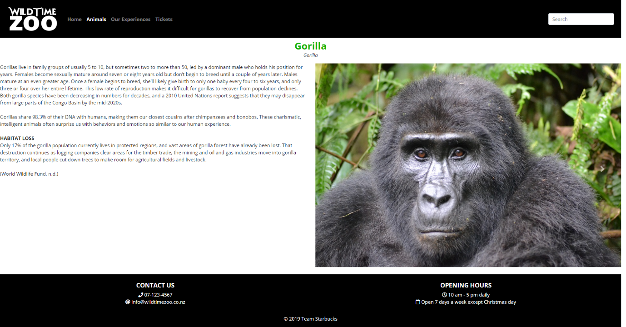

Kea 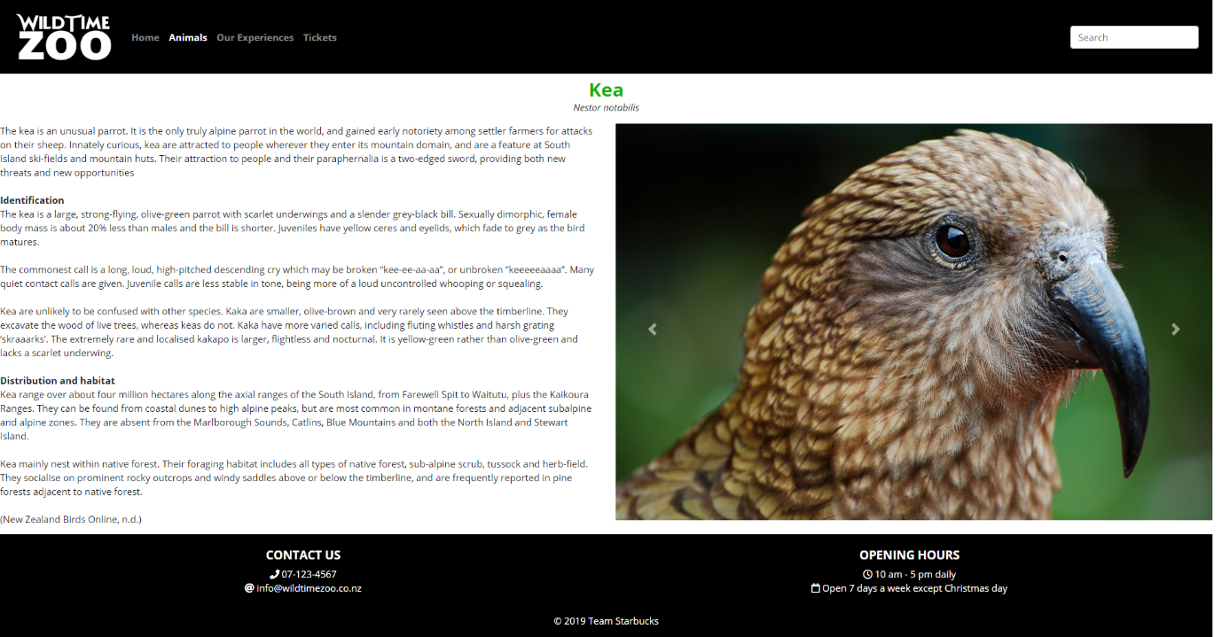

Kiwi 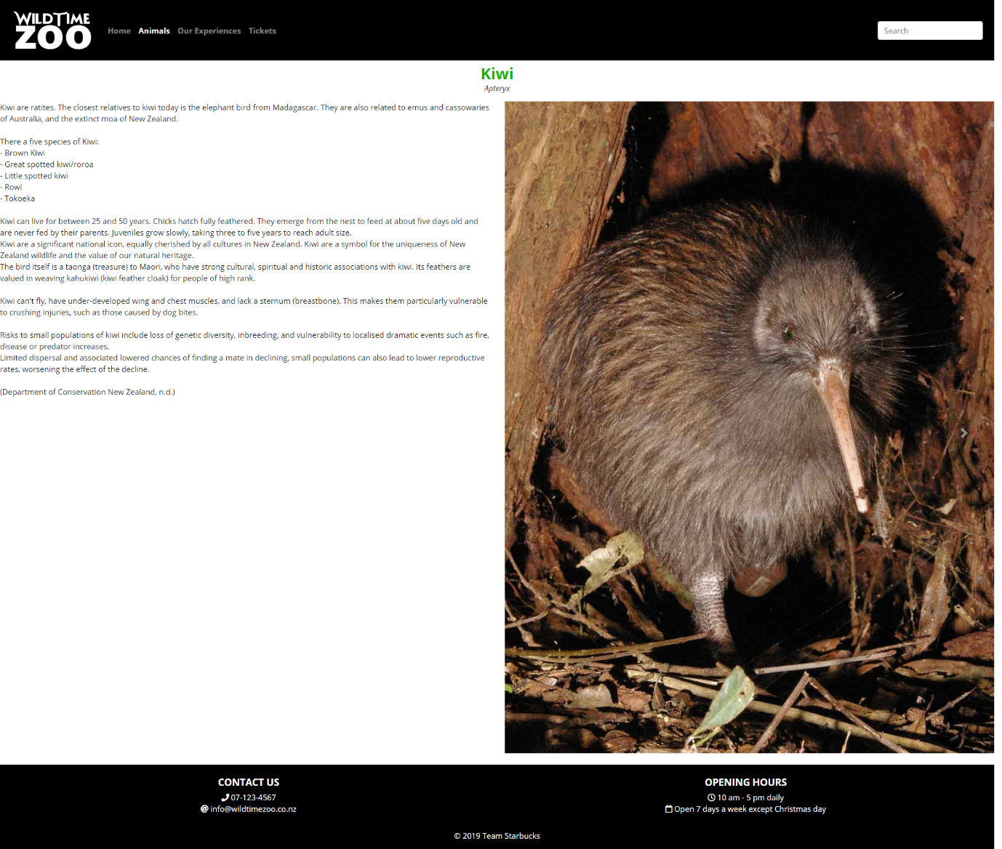

Panda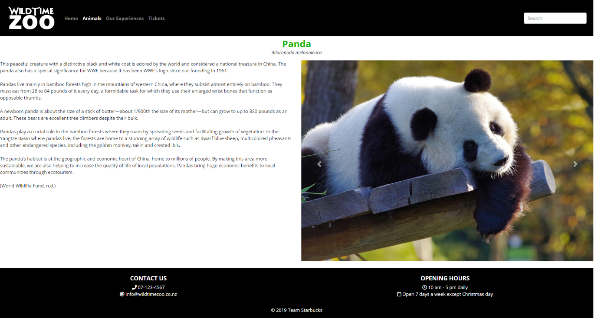

Giraffe

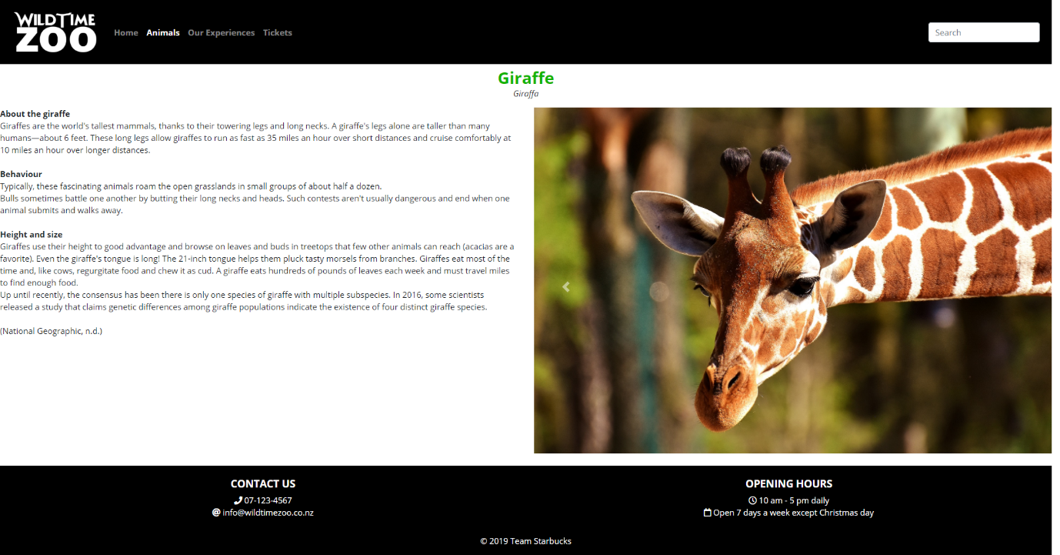

Birthdays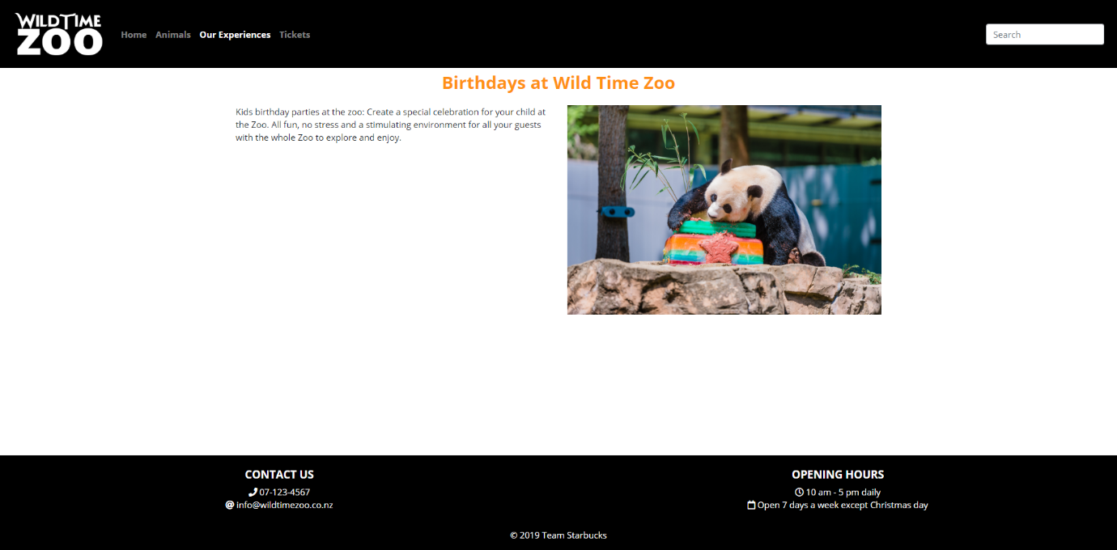

Encounters 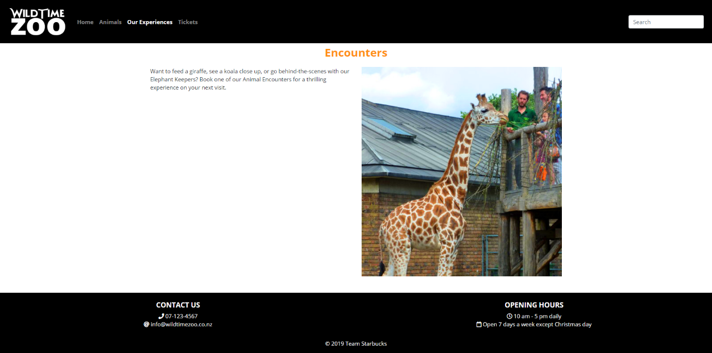

Facilities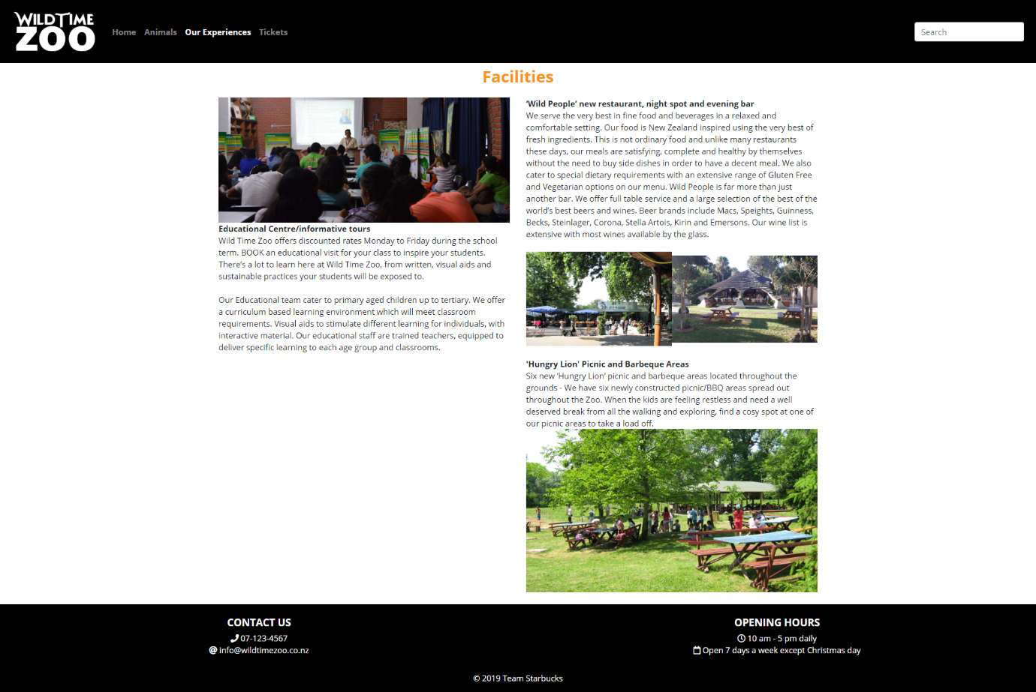

**References**

Alexandra. (Photographer). (2017). *Giraffe Wild Animals Stains Long* [Photograph]. Retrieved from <https://pixabay.com/photos/giraffe-wild-animal-stains-2222908/>

Alexandra. (Photographer). (2017). *Lion Predator Dangerous* [Photograph]. Retrieved from <https://pixabay.com/photos/lion-predator-dangerous-mane-3040797/>

Anderson, M. (Photographer). (2018). *Okarito kiwi on Blumine Island* [Photograph]. Retrieved from <https://en.wikipedia.org/wiki/File:Okarito_kiwi.jpg>

Banja Luka Zoo Picnic Area [Photograph]. (2011). Retrieved from <https://commons.wikimedia.org/wiki/File:2011--05-27_BL_zoo_59.JPG>

Bradford, A. (2014). *Lions: Facts & Information.* Retrieved from <https://www.livescience.com/27404-lion-facts.html>

Caulfield, A. (Photographer). (2007). *File: Kea (Nestor notabilis) -zoo -back.jpg* [Photograph]. Retrieved from <https://commons.wikimedia.org/wiki/File:Kea_(Nestor_notabilis)_-zoo_-back-6.jpg>

Department of Conservation New Zealand. (n.d.). *Facts about kiwi: NZ Native birds*. Retrieved from <https://www.doc.govt.nz/nature/native-animals/birds/birds-a-z/kiwi/facts/>

Doppelklecks. (Photographer). (2014). *Koelner Zoo: Zoo Restaurant Neubau 2014* [Photograph]. Retrieved from <https://commons.wikimedia.org/wiki/File:Koelner_Zoo_Restaurant_8459.JPG>

Eclair, R. (Artist). (2019). *Wild Time Zoo Map* [Digital Art].

Encyclopedia Britannica. (2019). *Toucan.* Retrieved from <https://www.britannica.com/animal/toucan>

Fischer, J. (Photographer). (2009). *Grosser Panda in Ocean Park, Hong Kong.* Retrieved from <https://commons.wikimedia.org/wiki/File:Grosser_Panda.JPG>

Fray, P. (Photographer). (2012). *Giraffe, Giraffa Camelopardalis, at London Zoo* [Photograph]. Retrieved from <https://www.geograph.org.uk/photo/3106147>

Gobetz, W. (Photographer). (2015). *Bronx Zoo: Giraffes* [Photograph]. Retrieved from <https://www.flickr.com/photos/wallyg/22090939382>

Gwyther-Jones, M. (Photographer). (2012). *Toco Toucan* [Photograph]. Retrieved from <https://www.flickr.com/photos/12587661@N06/8558944121>

Limassol Zoo [Photograph]. (2014). Retrieved from <https://commons.wikimedia.org/wiki/File:Limassol_Zoo_15.jpg>

Maungatautari Ecological Island Trust. (Photographer). (2007). *Te Tuatahi a nui, a male kiwi on Maungatautari mountain* [Photograph]. Retrieved from <https://commons.wikimedia.org/wiki/File:TeTuatahianui.jpg>

McKenna, J. (Photographer). (2012). *Photo of the powerful Silverback Cimanuka of Kahuz-Biega National Park, Democratic Republic of Congo* [Photograph]. Retrieved from <https://www.flickr.com/photos/jpmckenna/7992811277/>

Mountain Gorilla [Photograph]. (2018). *Gorilla Mountain Bwindi.* Retrieved from<https://pixabay.com/photos/gorilla-mountain-gorilla-bwindi-3928903/>

National Geographic. (n.d.). *Giraffe.* Retrieved from <https://www.nationalgeographic.com/animals/mammals/g/giraffe/>

Nature Animal World Gorilla Zoo Animal Monkey [Photograph]. (n.d.). Retrieved from <https://www.maxpixel.net/Nature-Animal-World-Gorilla-Zoo-Animal-Monkey-3562160>

New Zealand Birds Online. (n.d.). *Kea.* Retrieved from <http://nzbirdsonline.org.nz/species/kea>

Panda on a log [Photograph]. (2018). *Panda Giant Bamboo.* Retrieved from <https://pixabay.com/photos/panda-giant-panda-bamboo-china-3875289/>

Pietzsch, D. (Photographer). (2009). *In the eye of the kea* [Photograph]. Retrieved from <https://www.flickr.com/photos/pie4dan/3288237175>

Rhino Head [Photograph]. (n.d.). Retrieved from <https://pxhere.com/en/photo/341224>

Smithsonian’s National Zoo (Photographer). (2016). *Smithsonian’s National Zoo Celebrates Giant Panda Bei Bei’s First Birthday* [Photograph]. Retrieved from <https://www.flickr.com/photos/nationalzoo/29080395566>

Teachers in front of class [Photograph]. (2016). *School of Environmental Education of Noel Kempff Mercado Zoo*. Retrieved from <https://commons.wikimedia.org/wiki/File:25zoo.jpg>

Two Rhinos in a field [Photograph]. (n.d.). Retrieved from <https://pxhere.com/en/photo/174293>

Washburn, M. (Photographer). (2013). *A Toco Toucan looks for a snack at Ueno Zoo* [Photograph]. Retrieved from <https://www.yokota.af.mil/News/Photos/igphoto/2000922079/>

World Wildlife Fund. (n.d.). *Gorilla.* Retrieved from <https://www.worldwildlife.org/species/gorilla>

World Wildlife Fund. (n.d.). *Panda.* Retrieved from <https://www.worldwildlife.org/species/giant-panda>

World Wildlife Fund. (n.d.). *Rhino*. Retrieved from <https://www.worldwildlife.org/species/white-rhino>

Yancey, C. (Photographer). (2018). *Lion San Diego Zoo Mammal* [Photograph]. Retrieved from <https://pixabay.com/photos/lion-san-diego-zoo-mammal-animal-4016294/>